# Assignment 1: Charter, Scope, and Requirements Document

Project 1: API Development and Testing

University of British Columbia Okanagan

COSC499 - Summer 2022

Date: May 27, 2022

contacts:

## Wasi-ul-hassan Raza([wasmiester@gmail.com](mailto:wasmiester@gmail.com))

## Calvin Qu([Calvin000128@gmail.com](mailto:Calvin000128@gmail.com))

Po-Chia Wei([lunch33665566@gmail.com](mailto:lunch33665566@gmail.com))

Austin Wong(austinwong1@yahoo.ca)

1. **Project Objective 3**
2. **Stakeholder List 3**
3. **Major Milestones 3**
4. **Requirements 3**

**4.1 Functional Requirements 3,4**

**4.2 Non- Functional Requirements 4**

**4.3 Technical Requirements 4**

**4.4 User Requirements 4**

1. **Assumptions 4**
2. **High-Level Risks 5**
3. **Workflow and methodology 5**
4. **User Group and UML Diagram 5**

1. **Work Breakdown Structure 6,7,8**

**10.Approvals**

**1. Project Objective**

HelpYa is a startup that is trying to develop platform to connect client and businesses. Using said platform customers will be able to purchase search and negotiate services with the business of their choosing. The client described it as “imagine doordash but for trade work”. The client would like to design and develop an ios app for now with plans for cross-platform for android and web in the futuire.

**2. Stakeholder List**

* Harrison Larson
* Thomas Pattison
* Bright Anorchie
* Scott Fazackerley
* Project team

**3. Major Milestones**

1. Have a wokrbale demo that can make purchases from client to seller
2. Make Database to handle large user base and link it to the API
3. Add fields like location or business owner to the API. System recovery feature. Possibly add more features depending on time
4. QA all features and systems

**4. Requirements**

**4.1 Functional Requirements**

* Encryption for user data ie credit cards
* Scalability of 1000 users in the first year of production
* Recoverable system with backups. Flexible on downtime for adding features or updates
* Cross compatibility for future releases

**4.2 Non-Functional Requirements**

* One platform for both business and customer. When users open the app and try to make na acoount, it prompts them for what kind of user they want to be
* Admin suite for adding deleting and modifying account info
* Authentication maybe SABS 256 encryption

**4.3 Technical Requirement**

* Administrative tasks to add delete, and modify user and client accounts and information
* outputs are in json so can be queried by the front end
* Encryption of sensitive information like credit card info
* Use node js to make sure it is compatible and ensure it is able to be used cross platform in the future.

**4.4 User Requirements**

* Username and password to log in
* Business users need their business module including business name, business email, and business phone number.

**5. Assumption**

* Every team member finishes their task on time
* Every team member have skills in certain coding languages
* Communication is open and effective
* All milestones are met
* The program delivers to the clients on time

**6. High-Level Risks**

* Team members drop the course
* Team members get sick and absent
* Lack of communication in the team
* Low morale in team
* Finishing coding in parts that can not combine in a whole
* Dependants are not finished
* Could not meet client’s requirements
* Lack luster work
* Lack of communication with clients

**7. Workflow and methodology**

We will discuss requirements, design solutions, code solutions, test solutions with clients and get feedback from clients. Our team will use Kanban as our project workflow and we will have weekly meetings for the team. Every Thursday at 5:00 pm we will have a meeting with our clients.

**8. User Group and UML Diagram**

The target user group would be the companies or personal industries that are struggling to get more views and link popularity. The app will promote and advertise their names and descriptions throughout the mobile beauty market.

UML Diagram:

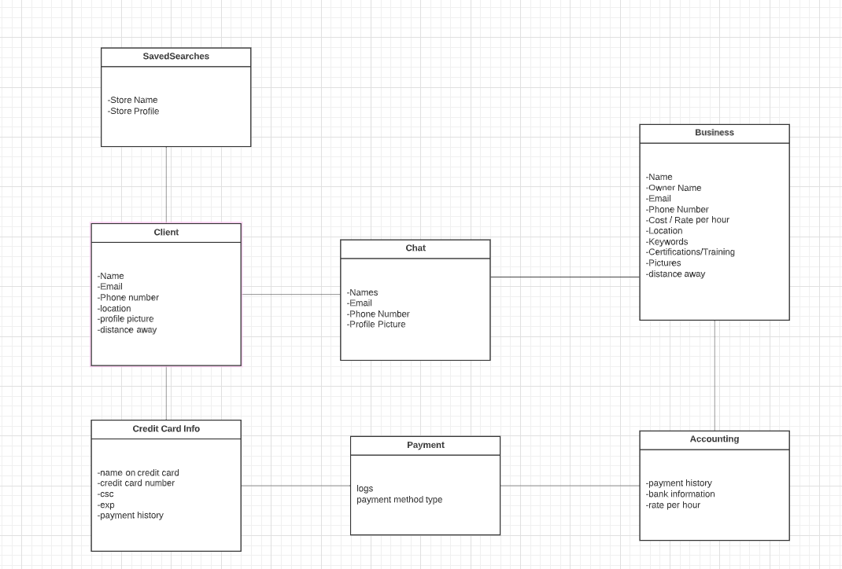

**9. Work Breakdown Structure**

| **Task List** | **Average Hours** | | | |
| --- | --- | --- | --- | --- |
|  | Wasi | Calvin | Pochia | Austin |
| **Functional Requirement** |  |  |  |  |
| **Database and back-end** | 2 |  |  | 4 |
| Initializing database with required tables and columns | 4 |  |  | 5 |
| Setting up the back-end starter code and choosing tech stack. | 2 |  | 2 |  |
| Making connections between back-end and database. | 3 |  |  | 3 |
| Adding and deleting feature | 2 |  |  | 3 |
| Data encryption. | 3 | 3 |  |  |
| **Meetings** |  |  |  |  |
| Client meeting weekly | 1 |  |  |  |
| Team meeting weekly | 3 | 3 | 3 | 3 |
| **Testing** |  |  |  |  |
| Front-end testing | 2 | 2 |  |  |
| Back-end testing | 2 | 2 |  | 2 |
| Integration testing | 1 | 1 | 1 | 1 |
| Usability tesing | 1 | 1 | 1 | 1 |
| **Documentation** |  |  |  |  |
| Scope and chartar document | 1 | 5 | 5 | 1 |
| Final report | 5 | 5 | 5 | 5 |
| Testing report | 2 | 2 | 2 | 2 |
| Peer evaluation Report | 2 | 2 | 2 | 2 |
| Readme file | 1 | 1 | 1 | 5 |

**10.Approval**

**Project Sponsor Signature __________________________________**

**Project Manager Signature __________________________________**